

THE GEORGE WASHINGTON UNIVERSITY

THE INSTITUTE OF BRAZILIAN BUSINESS & PUBLIC
MANAGEMENT ISSUES

THE MUNICIPALITY AND THE FISCAL
FEDERALISM IN BRAZIL

Karla Lopes Borges de Melo

WASHINGTON, D.C

2006

THE MUNICIPALITY AND THE FISCAL FEDERALISM IN BRAZIL
ECONOMIC AND INSTITUTIONAL ASPECTS

TABLE OF CONTENTS

- INTRODUCTION

- THE REAL CONCEPT OF FEDERALISM

  - HISTORICAL BACKGROUND OF BRAZIL

  - CURRENT SYSTEM IN BRAZIL

- BRAZILIAN MUNICIPALITY AS A SUBNATIONAL ENTITY

  - THE MUNICIPAL TAX SUBSYSTEM

  - ADMINISTRATIVE ISSUES

  - SOCIAL CONTROL

- THE REVENUE SHARING SYSTEM AND THE MUNICIPAL AUTONOMY

- FISCAL RESPONSABILITY LAW AND FISCAL FEDERALISM

- BRAZILIAN MACROECONOMIC EVOLUTION

- THE TAX REFORM AND MUNICIPAL FINANCE

- INTRODUCTION

“The Federal Republic of Brazil, comprised by the indissoluble union of states, municipalities and the federal district, constitutes a democratic state of law...” (Art. 1 of the federal constitution of 1988)

Due to its territorial dimensions, Brazil would necessarily demand a state organization rooted on an economic environment facilitating, among other things, the rational allocation of public resources, in such a way as to fulfill the expectations of all those who participate in it, despite of the proximity or great physical distances separating them.

There is no unique model to be found in existing federations. Each one presents its own characteristics that some way or the other undergoes changes over time. The Brazilian Federation has gone through great transformations over the years, both economically and politically. We have alternated between a high concentration of public resources in the Union and at other times, in sub-national governments. In 1988, the Citizen´s Constitution reinforced federalism as an additional guarantee of liberty, expanding the legislative dimension of the states, federal district and municipalities. Regardless what type of federalism we study; one of its foundations can be found in the distribution of governmental power by regional units. In most cases, this distribution is two-fold, generating two orbits of government: central and regional (union and federal states), which involve the same territory and the same people.

In Brazil, the municipalities are considered entities blessed with their own organization and governments as well as exclusive abilities. We believe this to be the “difference” that sets our federation apart from others and this municipal “independence” is manifested through its individual style of government, organization and administration. How to guarantee this municipal financial autonomy is one of the greatest problems in fiscal federalism. The attribution of tributary competence to federative entities and conferring through them the means to obtain resources is still not enough to guarantee this autonomy. In its turn, the intergovernmental distribution of tax resources accumulates problems and deficiencies, suffers changes and becomes more complex as time unfolds.

How can we distribute adequately and how can we finance the activities necessary for the success of the attributions, which correspond to such a distribution?
Our study aims to analyze the effect of constitutional transferences for municipal financing and especially their economic and institutional repercussion, macroeconomic evolution, including when the Fiscal Responsibility Law is applied.

As far as a possible we have studied the likely impact caused by federalist crisis, brought on by tax reform proposals, on municipalities. We have also commented on the main municipal taxes: the Any Nature Service Tax and the Urban Territorial Property Tax and the need to find other tax sources in order to guarantee financial autonomy.

Thus, we conclude the following with a deeper analysis of the apparent paradox involved in the inherent efficiency of fiscal federalism: the principle of efficiency demands that both attributions and public services be decentralized on the local level, but the same principle allocates a large part of these possible areas of tax incidence on the federal level, showing an asymmetrical relationship between attributions and federal reserves that end up needing to be corrected through vertical transferences.

2. THE REAL CONCEPT OF FEDERALISM

Federalism is a fragile and dynamic form of political cooperation to share power and responsibilities among diverse territorial units. Unlike a unitary state, sovereignty is constitutionally split between at least two territorial levels so that units at each level have final authority and can act independently from the others in some areas. Concomitantly, the central government exercises jurisdiction over the citizens of a given state independently of local authorities within the limits of a federal constitution.
In several fields of official activity, the central government tends to play a lesser role than state and local governments. A government performs well in strengthening public services when it understands the preferences of the local population. Services such as safety, education and health (including water supply and basic sanitation), fundamental in social and economic development, tend to be the responsibility of state and municipal governments, demonstrating the importance of good local administration.
The rate of power centralization or decentralization tends to create a balance between the different government levels. State and local governments are closer to the citizens, facilitating not only popular control of public acts but also cooperation between different public agencies. Federalism does not allow a far away central government to have absolute control.
Among modern states, the way how the public things are managed won features of extreme complexity, allowing the emergence of several kinds of power organization and attributions shared between regional entities, with more or less autonomy. Much recent philosophical attention is spurred by renewed political interest in federalism, coupled with empirical findings concerning the requisite and legitimate basis for stability and trust among citizens in federations.

Federalism first appeared in the US. There, the first doctrine was born, with the famous articles by Alexander Hamilton (with collaboration of John Jay and James Madison, using the pseudonymous Publius’s), published between 1787 and 1788 in New York and followed by a volume named “The Federalist”.

The mayor reason for these essays was essentially pragmatic: to convince the North American population (especially New York State) the advantages of federalism and to ratify the Constitution, aiming the economic development of the States.

The powers not delegated to the United States by the Constitution, nor prohibited by it to the states, are reserved respectively to the states, or to the people. Over the years, in response to national crises, many governmental powers – particularly those regarding social programs- were centralized to the federal level. However, in recent years, an increasing number of people in Capitol Hill and across the country want to “devolve” or transfer, power from Washington, D.C., to state and local governments.

The main question, which is most crucial to federalism, is how two sovereignties operate within one territory. Both the national and the local power each have attributes under the federal constitution that frees each one of them from interference by the other in specified areas. This is what makes federalism a complex political model. It is not always possible to find clear limits to federal and state power in the federal constitution. There are always gray areas in which both spheres believe they have the right to act and legislate. Thus, the potential for conflict is great.
Two basic things determine federalism: the constitutional rigidity and the existence of a constitutional organization controlling the law. The system can only work well if there is a pact between the different parts of the federation. The federal constitution should hold all provisions. A judicial authority with power to interpret the constitution is needed to resolve conflicts.

Federalism aims to reach a balanced situation of population, wealth, territory and power between autonomous entities. The regional differences should be corrected by cooperation mechanisms. The general rule is the existence of imbalance between the different regions in the Federation, mainly when the territory is big.

Federal systems are threatened by two extremes. On one hand, they risk excessive growth of the central government, suffocating local participation in decisions and distancing itself from local interests. At the other extreme, excessive decentralization tends to generate predatory competition between regions while stimulating fiscal laxity and separatist initiatives. Thus a federal pact must provide for a balanced distribution of power as well as an efficient process for dealing with conflicts between different jurisdictions.

2.1 HISTORICAL BACKGROUND OF BRAZIL

Federalism was conceived against the authoritarian and centralizing unitary State, which did not respect the internal differences of each nation. Decentralization is determined by juridical order and between political relationships developed throughout times.

Federalism has been important in Brazilian politics since at least 1889, with the overthrow of a centralized monarchy and the advent of a highly decentralized federal republic, which lasted until 1930. During that period, state oligarchies created a weak national government; there were no political parties, and states governors autocratically dominated politics within their states.

Brazil experienced two centralizing dictatorships since 1930, but federalism remains quite strong in comparative perspective. Getulio Vargas 1930-1945 dictatorship centralized Brazilian politics considerably; yet even during that period, Brazil continued to resemble a federal rather than a unitary system in both administrative and fiscal affairs. The democratic system established in 1945 expanded the power of the state governors, but the military dictatorship established in 1964 limited the importance of federalism in Brazilian politics by constraining subnational governments’ political and fiscal autonomy.

Since the redemocratization process initiated in 1980s, the Brazilian states again enjoy considerable political and fiscal autonomy. Resumption of direct elections for state governors in 1982 was crucial phase in the military regime’s strategy for a “slow, gradual and secure” return to civilian rule that finally took place in 1985. Local power regained strength after a period of political and administrative centralism.

The new governors wasted little time in demanding fiscal decentralization. Making use of their Congressional majority created during military rule, the poorer states won decentralization based on increasing federal transfers to states and municipalities, the main revenue source for most poor local governments, under the Constitution of 1988. Among the 27 states of the Brazilian federation, 12 of them, all in the Amazon and Northeast regions, get most of their revenue from federal transfers. Meanwhile, the richer states called for decentralized taxation, which would allow them to exploit their tax bases more intensively.

In spite the fact the Constitution of 1988 pursued “cooperated” federalism, with balance, freedom and administrative efficiency; these objectives were actually not reached. States and Municipalities had no incomes, being, however, replete of attributions and expenses.

2.2 CURRENT SYSTEM IN BRAZIL

The decentralization process in the Brazilian fiscal federalism was legally launched in 1988, when the new federal constitution came into effect. The new Constitution furthered the decentralization process, rather than mere deconcentration, of revenue mobilization and expenditure functions, as a reaction to the dictatorial period. Greater autonomy was granted to states and municipalities in debt, along with expenditure management and control. The Federal Government strives to recover its Tax Revenue share and increase its political power, limiting the space for sub national governments in fiscal matters. Consequently, The Fiscal Federalism autonomy intended by the 1988 Constitution was significantly impaired.

A considerable part of main public services competencies were assigned to local governments, which were supposed to perform these tasks relying on the financial and technical support by the federation. A large share of the national tax revenues was granted to these jurisdictions, directly or by means of transferences. Nevertheless, the higher level of local revenues was not translated initially, into higher standards of public services, due to a lack of coordination between states and federal government, in addition to technical and administrative deficiencies on the local level.

During the 1990´s the institutional framework underlying Brazilian intergovernmental relations experienced important changes that sough to strengthen vertical coordination between municipalities and state/national governments. A variety of new rules were gradually introduced. These rules intended mainly to establish the specific role of each government level for each kind of public service.

By 2000 an entirely new institutional environment was built. Health care and education programs were the main targets of these changes and it was in these areas that the institutionalization of intergovernmental relations advanced. Grants in these areas were constitutionally established by constitutional amendments, while enforcement rules were adopted.

The goal was to ensure better quality and access to public services. From a theoretical perspective these changes should improve public services by introducing new monitoring mechanisms. From another perspective these changes limit local government’s autonomy and hinder local government’s capacity to develop policies suitable to local conditions. The arguments favoring each position are not conclusive and the dilemma is long known in fiscal federalism literature.

Now Brazil is facing an internal war in the struggle to strengthen its public finances. Its federal system is weakened by ceaseless pressures on its resources by state and municipal governments that tax too little and spend too much in order to advance the careers of local politicians.

Local governments are aware of this situation. Knowing that they can rely on the Union to bail them out, municipal governments tend to relax expenditure controls and borrow more, exposing themselves more and more to an economic shock.

- BRAZILIAN MUNICIPALITY AS A SUBNATIONAL ENTITY

Unlike the United States, where municipalities are not object of the Federal Constitution, representing free creation of States, in Brazil the municipality is a person of Intern Public Law, with constitutional autonomy guaranteed by personal administration, especially enacting and collecting taxes by their own competence and the organization of local public services. The State Constitution and the Municipal Organic Law can establish rules for the creation and operation of city halls.

Municipal governments have become important elements in Brazilian federalism. The role of the local government is changing significantly, not only due to their increase revenue capacity, but also according to their active role in service delivery, mainly in the social arena. The main challenges currently faced by municipal governments are to avoid the rise in payroll expenditures relative to outlays on more productive programs, particularly in the social and infrastructure areas. They must improve the public expenditure efficiency, reducing outlays in both legislature and administration. They have to create mechanisms to increase revenues from their own taxes.

Differently from other known republican experiences, the Brazilian Federation did result from people’s conviction, but it was rather decided, by the highest levels of authority to divide the unitary State that prevailed during the Imperial Regime. At the beginning of the Federation, the Local Government represented the weak link of the chain depending heavily on the State Governments.

In 1934, the Local Governments were assigned with revenues proceedings from the taxes on Rural and Urban States, as well as taxes on local services and permits. An important innovation adopted was the principle of tax revenues partition.

The changes introduced in the Fiscal Federalism domain by the Constitution of 1988 radically altered the Fiscal Federalist model adopted during the 60s by the military regime, although little change was introduced on the design of the tax system itself. The Federal Government share in the tax revenues sharply decreased, mainly benefiting the local governments, since the State’s share in the total Tax Revenues remained practically unaltered. Concomitantly, the autonomy for States and Municipalities to impose new taxes or change the percentage of the existing ones was increased.

The political drive for decentralization and for local government support was especially strong when the Municipalities were granted the status of Federation entities, which is not usual in the Federal regimes. Unlike other federal constitutions, which typically define municipal governments as creatures of their respective states, the Constitution of 1988 establishes the municipal government as a third tier of government with a constitutional status equal to the states.
The enhancement of the financial capabilities of State and Local governments were ensured through the creation of new taxes, the raising those already existent and by increasing the share over taxes collected at the Federal level and transferred to State and Local Governments.

The Federal government had its Financial Capability endangered with the drastic revenue reduction, which occurred because the state and local governments were not assigned corresponding duties along with the new Tax Revenues they would be entitled. That problem was worsened by the fact that in areas such as health care and education, social security and welfare, agriculture and food distribution, sanitation and housing, public safety, public transport, environment control and others, there is not clear division of responsibilities among different levels, often leading to expenditure overlap across different levels of government.

Furthermore, to cope with that lack of Tax Revenues, the Federal Government acted in two ways: increasing the tax burden by creating new cumulative taxes or raising the rate of those existent, choosing taxes that were not supposed to be shared with other government levels, and by provisionally reverting the increase of the Tax Revenue Share of both State and Local Governments approving a Constitution amendment.

Consequently we can observe a drastic tax burden increase and that growing portion of those new Revenues were collected and kept by the Federal Government. It is important to highlight these figures for two reasons: first, these taxes are of the type not shared by other government levels, second they are cumulative taxes, and therefore, tend to worsen the quality of the tax system.

3.1 THE MUNICIPAL TAX SUBSYSTEM

The main directives on taxation are provided by the Federal Constitution, which establishes the general principles of taxation, the limitations on the power to tax, and the tax competence across levels of government.

The Municipal Tax Subsystem is instituted by the Constitution itself, which establishes that the Municipalities may collect taxes. The administrative-political autonomy, which is an essential characteristic of our federative system, confers to each government level the possibility of instituting taxes, fees (due to its police force or to the use of public services) and improvement charges (due to public works).

Municipalities shall be governed by an Organic Law, observing the principles established in the Federal Constitution and in the State Constitution. The Municipal Tax Subsystem is based upon the Municipal Tax Legislation.

In order to ensure that the local administration, which is closely related to the lives of inhabitants, will be carried out smoothly based on the responsibility of both local governments and inhabitants and that local governments will be able to perform the duties entrusted to them by the inhabitants, it is important to enable residents to pay taxes at locations convenient to them and audit how their taxes are being used. This will improve the inhabitants' understanding of local administration and awareness of their benefits and burdens. In this respect, the local tax system is the base of local autonomy in Brazil.

The Local Tax Bureau strives to ensure a fair and appropriate sharing of the local tax burden and to increase the stability and flexibility of local tax resources from the perspective of promoting decentralization.

Regarding the local tax revenues that serve as the basis for local autonomy, it is necessary to establish a local tax system that enables stable tax collection by taking the following measures with the aim of ensuring that local governments will be able to carry out their own administrative and fiscal policies more independently and autonomously along with the progress in decentralization.
- Making efforts to enhance and secure local taxes while respecting local governments' taxation autonomy for the purpose of reducing the gap between local government expenditures and local tax revenues.
- Securing necessary general tax resources including local tax revenues while considering the possibility of abolishing or reducing national subsidies to local governments as well as the nature and degree of such subsidies.
- Considering an ideal way to allocate tax resources between national and local governments while taking into account the sharing of roles between national and local governments.
Although municipalities are still to a considerable extent dependent on state and federal transfers, it is important that their total income sources are clearly defined. This allows local governments to be certain of their future income flow, which is essential for an effective medium and long-term planning. The fact that municipal governments do not need the approval of higher-level authorities when assembling their budgets provide them with a powerful tool to prioritize and spend on those issues they consider to be most important.

Understanding Federalism as a type of decentralized alliance where political power is shared, autonomy appears as a result of the power of sub national entities to elaborate and enact their own laws respected the limits imposed by the Brazilian Constitution.

In the Tax System, this autonomy is fundamental to understand the political pluralism because it allows the entities to follow standard rules and to manage the competences granted by the federal constitution, without interference from others centers of power.

The need that income generated by other governments, in the case of Brazil, by the Union and the States, is shared with the municipalities, checking them as a stable source of resources that can be managed with autonomy and be compatible with their needs is overlooked by the federation.

The Municipalities have the competence to institute taxes on urban buildings and urban land properties and services of any nature, defined by supplementary law, main sources of own revenues and intervivos transfer by onerous act, of real property. Besides this tax, they can institute fees, by virtue of the exercise of policy power or for the effective or potential use of specific and divisible public services. They also levy charges for public illumination to maintain this kind of service. They can institute benefit charges, it is a kind of tax they can collect from landowners where the price of the properties was valued by public services. Another charge can be demanded from their employees to pay for their social welfare.

Beside all these municipal revenues, the Municipalities take part in the intergovernmental transfers of constitutional nature or originating from budget law. These revenues can be of tax nature or not.

These tax revenues are represented by municipal quotas from the following State taxes: tax on the circulation of goods and transportation and communication services (ICMS) and tax on motor vehicles (IPVA). Being 25% of the ICMS and 50% of the IPVA. They also take part in federal revenues coming from the Income Tax and Tax on Industrialized Products through the Municipalities Participation Funds.

There are some revenues that do not come through tax revenues. The federal government reimburses the municipalities that spend with health services and there are some voluntary transfers resulting from political decisions, plans or pacts, and amendments introduced in the Union Budget and in the State Budget.

Related to the judicial aspect, the Constitution allows the Municipalities to institute taxes through Ordinary Law. They must follow the rules of supplementary laws, including the National Tax Code. They have also to obey the Municipal Organic Laws, provided that they do not conflict with the meaning of the law at the National Congress.

Any Nature Service Tax – ISS

The ISS is a municipal tax on gross billings for certain services designated by the Supplementary Law 116/2003. The applicable rates to be determined by each municipality can vary between 2% and 5%.

Generally speaking, the any nature service tax is levied by the municipality in which the company is headquartered. They are some exception to this rule such as services including assembly, construction and demolition, among others.

New regulation, effective as from January 2004, resulted in important changes to the ISS legislation. The original list of services subject to the tax was expanded and the import of services is now subject to the ISS. Additionally, ISS is not levied on service exports, unless when the results of these services will be applied in Brazil.

Urban Property Tax - IPTU

Efforts to increase the responsiveness and accountability of local governments -- as well as fiscal constraints at the central level -- have prompted an interest in reviving the urban property tax as a major source of municipal revenue. At present, the urban property tax is the most widely used municipal tax instrument in the developing world, but typically accounts for less than half of municipal recurrent revenues.

Property tax yields can be increased by either increasing tax rates or reducing losses arising from evasion and maladministration. In the case of the property tax, there is a strong argument for beginning with the latter. Efforts to increase rates alone would exaggerate the inequities arising from existing maladministration, placing the burden of that raise on those who already pay their fair share, whereas improvements in administration place the burden on those who evade.

A focus on administration reaches the goal of increasing revenue while improving fairness. The Brazilian experience with urban property taxation yields several lessons on both the practice of property tax administration and the process of implementing administrative reforms. Brazilian municipalities have found solutions -- wholly or partly successful -- to the following problems confronting property taxation: rapid urban growth; scarcity of skills; inaccessible market data; inflation; disputed liability; and slow judicial procedures.

The applicable rates to be determined by each municipality can vary according to the Tax Code of each city. The destination of the property is important for rate it.

3.2 ADMINISTRATIVE ISSUES

The Federal Constitution explicitly recognizes the local government level and establishes that the municipalities as well as the states are autonomous regarding their internal affairs. Local governments are also ruled by a municipal law (lei organica) and a fiscal code based on the principles of the national constitution.

Municipal governments are constituted by a Mayor (prefeito), a Vice-Mayor and a Council ( Camara Municipal). The Federal Constitution states that the Mayor and Vice-Mayor shall be elected by popular vote every four years with only one reelection. Councilmen are elected by popular vote every four years with reelection allowed for indefinite periods. The size of the City Council will be proportional to the municipality’s population. In no case will the number of members be below nine or above fifty-five.

As elected authorities, the members of the Council – including the Mayor – are autonomous. There is no hierarchical structure among them and nobody can be removed from his/hers position due to his/hers votes and opinions while exercising his/hers roles. The role played by political parties is limited to the nomination of candidates for the council. So, they really have no power in determining its final composition.

Regarding municipal autonomy with respect to the other two levels of government, it is remarkable that the Federal Constitution establishes that the states and the federal government (The Union) will not intervene in the municipalities, expect in cases the municipality: stops paying its debts for two consecutive years, does not render the due accounts, does not apply the legally required amount of resources in education and healthy violates the Federal and State Constitution principles or refuses to observe a judicial order or decision.

In short, this means that state and central government officials have no actual decision-making roles in the local government, but can intervene when the local governments do not observe the laws.

Among the responsibilities and prerogatives that municipalities are entitled to exercise, the following stand out the right to legislate over issues of local interest, to create, organize and suppress districts according to the state legislation and to organize and provide directly or under concession, public services of local interest.

Local governments are responsible for urban planning and land development, public transportation, police, parks and gardens. It is nevertheless remarkable that, municipalities are also involved in the provision and distribution of energy, housing, health care and education.

In some cases local governments actually shared responsibilities with states and the central government. The formal distribution of functions is certainly decentralized. The central government maintains a shared responsibility only in regard to water and sewage, housing, healthy care and education. In this last case, municipalities are responsible for the nursery, and primary levels.

Therefore the municipalities have the power to legislate upon matters of local interest, supplement federal and state legislations where pertinent, institute and collect taxes within their jurisdiction, as well as to apply their revenues, without prejudice to the obligation to render accounts and publish balance sheets within the periods established by law, create, organize and suppress districts, with due regard for the State legislation, organize and render, directly or by concession or permission, the public services of local interest, including mass-transportation, which is essential in nature, maintain, with the technical and financial cooperation of the Union and the State, programs of pre-school and elementary school education, provide, with technical and financial cooperation of both Union and State, health services for the population, promote, wherever pertinent, adequate territorial ordaining, by means of planning and control of use, apportionment and occupation of the urban soil, promote the protection of the local historic and cultural heritage with due regard for federal and state legislation and supervision.

The recent fragmentation of the local government units, as well as the institutionalization of federalism in three levels, is a political phenomenon restricted to Brazil. Several new municipalities were created in the Brazilian states between the years of 1988 and 2000. This is a historical-institutional approach.

The state’s power to decide predominated among the decisions favoring the creation of the municipalities: because the consolidation of the fiscal decentralization ensured the stability of fiscal transferences to the municipalities and the regulation decentralization of the new municipalities passed on to the states; the states conquered a great autonomy in the power to define the municipality creation process. Additionally, the exclusive prerogative voters have to initiate a transaction process along with the popular manifestation through plebiscite, limited the capacity the executive had to control the legislative power.

3.3 SOCIAL CONTROL

In recent years, local governments, rather than states, have become important elements in the Brazil federalism. The role of municipal government is changing significantly, not only due to their increased revenue mobilization capacity, but also in terms of their more active role in service delivery, particularly in the social arena. It has been argued that the fiscal decentralization provisions in the Constitution of 1988 were essentially a “municipalization” process of revenue mobilization and service delivery.

The main challenges currently faced by municipal governments are to avoid the rise in payroll expenditures relative to outlays on more productive programs, particularly in the social and urban structure areas, to improve the efficiency of public expenditure by, for instance, reducing outlays in both legislature and administration, and to boost local revenue mobilization, specially in the light of growing demands for social security expenditure at the local level.

Municipal governments have progressively taken on the expenditure functions assigned to them by the Constitution in the social area. This has often required financial assistance from the federal government, in addition to the existing mandated revenue-sharing arrangements. Additional federal assistance has not only reduced the risk of delivery disruption in the cases where capacity was limited at the local level, but also ensured the timely transfer of funds to service delivery agents. This has been the case in health care. More importantly, transfers on the basis of minimum per capita expenditure levels have been a key incentive in many programs, in the areas of primary education and preventive care. As local governments strengthen their role in service delivery, it is expected that federal outlays will be reduced on those programs where expenditure assignments overlap across government levels.

Greater autonomy in policymaking and emphasis on municipal governments in service delivery are necessary steps toward improving performance indicators in key social areas such as health care, education, social assistance, as well as urban planning and infrastructure. Municipalities are required to earmark 15 percent of their revenues to finance outlays in primary education. They were not able, or willing, to perform the functions assigned to them by the Constitution for fear of shortfalls in transfers from the federal government. To deal with this problem, a new federal levy on financial transactions (CPMF) was created with revenues earmarked for financing health care expenditure, and the municipalities are now required to earmark 15 percent of their revenues to finance outlays in health care.

Since 1998, the coverage of the municipal primary education system has increased, and the municipalities have become the main providers of primary education. Therefore, more policymaking autonomy has been exercised at the local level with increase use of demand-driven, result-oriented, participatory administration in public schools, particularly after 1995.

Recent initiatives have favored joint ventures between the federal government and the municipalities. These initiatives consist on focusing social policies and public outlays on existing programs in poor municipalities. The priority programs are in the areas of preventive health care, primary education and income support.

Citizens and civil society organizations play a more prominent role in the new democratic regime in Brazil than under previous democratic experiences. Efforts to promote transparency, accountability, and participation have led citizens, community organizations, social movements, and nongovernmental organizations to demand a more expansive role in decision-making venues. Brazil, Latin America’s most densely inhabited and most decentralized democracy, has witnessed the proliferation of participatory institutions at the municipal level, granting citizens access to decision-making venues as well as the right to engage in oversight activities. Participatory institutions, such as participatory budgeting, represent an effort to devolve and broaden decision-making venues with the potential to place a check on mayor’s prerogatives.

The operation of and outcomes from participatory institutions appear to be intimately related to the breadth and intensity of support extended by mayoral administrations. Mayors must be willing to delegate authority to citizens. Likewise, citizens and civil society organizations interested in the expansion of participatory institutions must work closely with mayoral administrations to ensure that the rules are followed and public policy projects are implemented. The delegation of authority to citizens has the potential to expand accountability at the local level as citizens contribute to policymaking decisions and work on third-party oversight committees. Yet there is also the risk that the insertion of civil society organizations into participatory policymaking venues based on their close political connections to elected mayors may subvert the development of “checks and balances”.

In Brazil, participatory institutions have been implemented at the behest of political strategies promoted by “participatory” or leftist sectors of Brazil’s political and civil societies. These institutions are designed to overcome numerous social and political problems, such as low levels of accountability, inefficiencies in social service provisions, and corruption, all of which hamper efforts to improve the quality of democratic governance. Brazilian democracy is plagued by a “private” state, where most mayors continue to treat their municipal administrations as personal fiefdoms. In many municipalities, the policymaking process is undertaken far from the prying eyes of politicians and civil society organizations. Participatory institutions, their advocates often argue, will make a dent in Brazil’s social and political inequalities by allowing citizens to deliberate in public, negotiate over the distribution of public resources, and hold government officials accountable.

This innovative institutional format incorporates citizens and municipal administrative officials into a policymaking process in which citizens directly negotiate over the distribution of public resources. In the most successful cases, participatory budgeting has had the power to transform basic state-society relations, redistribute resources to under serviced neighborhoods, and create transparency in the budgetary process. In less successful cases, participatory budgeting creates opportunities for activist to raise awareness of public policies, which is still a desirable outcome but has a much more limited impact on policymaking.

Why would a mayor delegate authority to decision-making bodies dominated by citizens?
And once a mayor initiates a participatory decision-making process, what influences the mayor’s capacity to implement particular policy preferences? The first question taps into the mayor’s willingness and preference to redesign policymaking processes. The second question situates mayors in the municipality’s broader political environment to demonstrate how Brazilian mayors face a series of constraints that limit their ability to implement their desired policies.

The concept of accountability has been employed by political scientists to account for variations in the quality of Latin America’s new democratic regimes. Theorizing about diverse arenas, such as institutional authority, citizen participation, and political contestation, is a central concern as political scientists seek to move beyond the “consolidation” debates to assess the processes that generate political renewal.

Does the expansion of decision-making venues limit mayoral authority? Does it undermine the responsibilities and duties of legislative bodies? Is accountability enhanced if citizens must still depend on mayoral administration? The focus of the accountability debates has been on how one agent (the voters, the courts) can control another agent (elected officials, the executive branch). One weakness of such a focus is that the conceptual variants-horizontal, vertical, and societal-tend to run on parallel tracks, unable to show how citizens, civil society organizations, politicians, and institutions may place interlocking checks on the ambitions of other actors.

Participatory institutions, by contrasts, tap into all three dimensions of the debates.
Participatory institutions have the potential to act as a check on the prerogatives and actions of mayoral administrations, to allow citizens to vote for representatives and specific policies, and to rely on the mobilization of citizens into the political process as a means to legitimate the new policymaking process.

Parte superior do formulário

4. THE REVENUE SHARING SYSTEM AND THE MUNICIPAL AUTONOMY

Brazilian municipalities have different sources of income. As I have mentioned before, among their own income sources are taxes on property and public services, licenses, fees and income from diverse economic activities and utilization of municipal assets. Municipalities also receive income from the levy of federal and state taxes. Being a way of strengthen the administrative-political and financial autonomy of government levels, the Brazilian Constitution defines a system of “unconditional” transfers between the Union, the States and the Municipalities, which can be either direct or through the creation of special funds (indirect). Regardless the type, transfers always occur from higher to lower government levels, i.e., in the case of cities, from the Union to the Municipalities or from the States to their respective Municipalities.

Direct transfers to Municipalities, as constitutionally defined, are the following: municipalities are entitled to keep the total income tax collection they withhold at source on income payments they make or on payments made by autarchies or foundations they constitute and maintain, municipalities are entitled to 50% of the tax collected on rural land property (ITR) levied on real estate within their territory and are also entitled to 50% of the tax collected from motor vehicles (IPVA) registered in their territory. The main fact is that the municipalities are entitled to 25% of the tax collected on the circulating of goods and transportation and communication services (ICMS) (3:4, at least, proportionally to the value added through operations carried out in their territories and up to 1:4 as provided in the State Law). Municipalities also receive by transfer 70% of the IOF-Gold collection (as a financial asset).

The following fund is used to carry out the indirect transfer. The Municipalities Participation Fund (FPM): constituted by 22.5% of total IPI and IR collection is proportionally distributed according to the population of each unit. 10% of the fund is set aside for the municipalities of the capital cities.

The distribution mechanisms of these resources are established in the Federal Constitution as well as in specific laws. The resources are to be transferred monthly and in no case can states and nor the federal government restrict or withhold such transfers. Furthermore, local governments have the right to issue debt, internally and externally according to their payment capacity, even though they need the approval of the Federal Senate. In sum, as stated in the Federal Constitution, of the total federal fiscal income, local governments get 23%.

It is noteworthy that municipalities do not need the approval of any state or central authority to design and implement their budget. However, local governments are required to publicity inform on an annual and monthly basis about their financial statements and the implementation of their budgets.

Therefore, the Federal Government has limited control over sub national tax administration, budget formulation, execution, oversight, wages and investment policies. Greater autonomy was granted to municipalities in the debt and expenditure management control, reflecting the return to democracy when important tax bases were returned to the cities. On the other hand, to compensate for at least some of these revenue losses at the federal level, the new Constitution widened the base for social security contributions, and increased the tax burden on payroll and earnings, and subsequently on financial transactions. These revenues are not shared with the municipalities.

We must realize that constitutional provisions on revenue sharing favor local governments in detriment of the federal government without a clear devolution of expenditure functions to them. As was already mentioned the federal government has little jurisdictional power over expenditure management and control at the municipal level. These rigidities in revenue sharing arrangements also contributed to delay sub national fiscal adjustment, since the federal government efforts to increase revenues have also led to an increase in total sub national revenues via revenue sharing.

In short, three basic characteristics can be singled out in the Brazilian Revenue Sharing System. First, most transfers are of constitutionally mandated, revenue sharing type, rather than discretionary. This reduces the scope for nontransparent, politically motivated transfers in the form of discretionary grants. Second, the Constitution of 1988 deepened vertical imbalances in intergovernmental fiscal relations by requiring the federal government to share the revenues of two of its main tax bases with the municipalities. Thus, the federal government has increased emphasis on mobilizing revenues that are not earmarked for sharing with municipalities, leading to a heavy tax burden, which encourages informality in the labor market and impairs competitiveness.

Third, it has been previously mentioned that there are some transfers for municipalities, which could be called voluntary transfers, which originate basically from parliamentarians’ individual amendments, according to the federal budget. Those transfers can be destined for any propose. That fact indicates that the parliamentarian political influence in the federal government is important for the execution or not of his/her amendment, for there are many political agreements involving the Congress and the budget execution. In spite of that, the simple direct observation of the mayor’s party does not allow us to infer whether municipalities governed by opposition mayor received less resource than those governed by members of parties who support the President.

- FISCAL RESPONSIBILITY LAW AND FISCAL FEDERALISM

The Fiscal Responsibility Law establishes public finance rules enforcing responsibility in fiscal management and other provisions. Responsibility in fiscal management presupposes well-planed and transparent actions to prevent risks and correct deviations that may affect the balance of public accounts, by compliance with revenue and expenditure results targets, observing limits and satisfying conditions regarding tax breaks, generation of personnel and social security expenditures, among others, consolidated and security debt, credit operations, including those involving revenue anticipation, issued guarantees and outstanding liabilities.

The provisions of this Supplementary Law apply to the Federal Government, the States, the Federal District and the Municipalities. The enactment of the Fiscal Responsibility Law has been instrumental in imposing hard budget constraints at the municipal level. It has been widely accepted that municipal debt negotiations with the federal government could be interpreted as a bailout operation unless followed by institutional changes aimed at imposing hard budget constraints at the municipal level. These regulations include provisions for borrowing, indebtedness, tax expenditures and governance. The law forbids further rescheduling of sub national debts contracted after May 2000.

Under the law, transparency is the key component of social oversight, and involves the publication of reports and statements on budget outturn, providing taxpayers with information regarding the use of the resources they make available to the authorities. The Fiscal Responsibility Law includes the following rules and principles for the municipalities:

Personnel expenditure limits – the law limits personnel expenditure as a share of net current revenue for the municipalities.
Public indebtedness limits – these limits will be established by the Senate upon the proposal of the President of the Republic.
On governance, the law requires muti-year budgets with three-year targets for revenues, expenditures and indebtedness.
Offsetting mechanisms for recurrent expenditure – to create a recurrent expenditure (for a period exceeding two years) the authorities must designate a source of revenue or reduction in other expenditure.
Public finance control mechanism for election years – the law forbids credit operations with advance budget revenue during an administration’s last year office, and prohibits the increase of personnel expenditure during the 180 days prior to the end of the term.

The expenditure ceilings applicable to the municipalities are (60 percent of net current revenue): Legislation Branch, including Court of Auditors, 6 percent and Executive Branch, 54 percent.

Should total personnel expenditure exceed the limit by 95 percent, the branch that incurred the overrun will be disallowed to: granting benefits, or any kind of remuneration increase, adjustment, or adaptation, creating positions, jobs or functions, apply career path changes involving expenditure increases, establish public offices, hiring or contracting any type of personnel – although staff in the areas of education, health, and security should be replaced in the event of retirement or death, contract overtime, except in those situations provided by the budgetary directive law.

A key policy question is whether Brazil reached a cooperative federalism solution. The recent changes in the legislation have laid the foundations for a rules-based system of decentralized federalism that leaves little room for discretionary policymaking at the sub national level. This was motivated by the recognition that market control over sub national finances should be replaced, or strengthened, by fiscal rules as well as appropriate legal constraints and sanctions for non compliance at all government levels.

- BRAZILIAN MACROECONOMIC EVOLUTION

The table below presents the macroeconomic evolution during the last ten years, the present situation of domestic and foreign accounts, and main indicators of the economic situation in Brazil. The data covers the periods 1995 / 2002 (two terms of the previous government), 2003 to October 2005 of the present government, and the situation in October 2005. Important aspects that went unnoticed by the media when they occurred are highlighted throughout the text.

Macroeconomic Evolution
Domestic Accounts |  | 1995 / 2002 | 2003 / 2005 | Oct 2005
Primary Result | % GDP | 1.7 | 4.7 | 5.2
Interests | % GDP | -8.8 | -7.5 | -7.6
Nominal Result | % GDP | -7.1 | -2.8 | -2.4
Debt / GDP | % GDP | 55.5 | 51.1 | 51.1
Real Interest Rate | % Year | 15.9 | 10.9 | 13.4
Foreign Accounts
Balance of Trade | US$ billion | -1.1 | 33.5 | 41.9
Current Negotiations | US$ billion | -23.3 | 9.6 | 13.1
Debt / Exports | Unit | 3.5 | 2.3 | 1.5
Economic Situation
GDP | % Year | 2.3 | 2.8 | 3.0
Inflation (IPC)(Consumer Price Index) | % Year | 10.2 | 6.7 | 4.9
Production | 1992 = 100 | 122.8 | 136.3 | 142.4
Real Salary | 1992 = 100 | 109.9 | 110.4 | 118.3
Formal Employment | Dec/04=100 | 86.6 | 98.6 | 101.9
Default | % | 8.8 | 4.7 | 4.7
Source: Central Bank – Domestic and Foreign Accounts, inflation and default; Industry Federation – Production and Real Salary; Ministry of Labor and Employment - Formal Employment - Note: the Debt / GDP are that one at the end of each period having begun in Dec/94 at 30.4%.

The domestic accounts present the fiscal results, indebtedness and real interest rates of the public sector. They express how, throughout time, the balance between revenue and expenses behaved, and the debt that was generated by the accumulation of deficits.

After a yearly average medium fiscal deficit of 7.1% of the GDP during the eight years of the previous government, the average deficits of the present government during two years and ten months were reduced to 2.8% of the GDP, being presently at 2.4%. This level is below that one of most countries in the Euro zone and the United States of America. Therefore, in this aspect the country evolved from a situation of high fiscal deficits, to a comfortable position in the international environment.

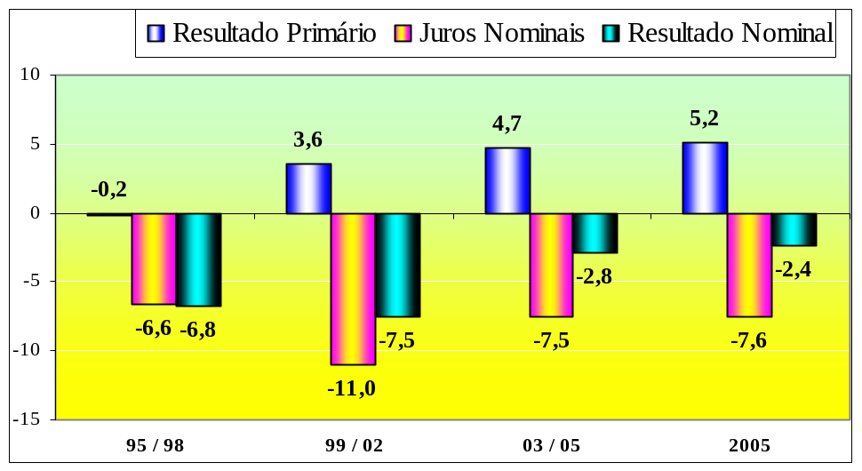

The Debt / GDP ratio is another important indicator of the public financial health. It is the most used by analysts to assess the fiscal situation of the public sector. In this analysis, besides the relation level, its trajectory is of interest. As the proportion decreases, the more effective the fiscal sanitation becomes and the lower is the risk of default in the public sector.

The graph below presents this development covering the period from 1981 to October 2005:

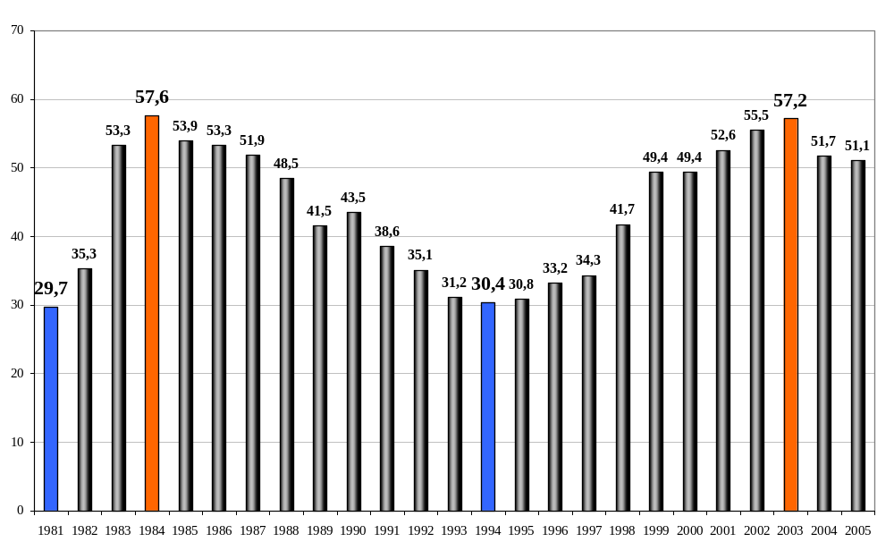

After reaching a peak in 1984, the debts continuously decreased until 1994. They experienced an important growth, of 25.1 percent, in the previous government going from 30.4% of the GDP in the end of 1994 to 55.5% by the end of 2002. They reached 57.2% in 2003, falling to 51.1% in October 2005. The media was absent in regard to the past government’s debt.

The improvement in the current government is due to four factors: higher GDP growth, increase in the primary surplus, lower real interest rates, and valorization of the real in relation to the dollar reducing the weight of the public debt’s foreign component. Even though the indebtedness situation was reverted, its level continues high with a very slow decreasing rhythm, as observed in 2005, due to high interest rates and low economic growth.

The real interest rate (nominal rate, inflation excluded) was of 15.9% per year in the previous government and of 10.9% in the present government, having increased to 13.4% by the end of October.

These rates are the main responsible for the high indebtedness level and for the deficit in the country’s public accounts. They hamper the economic activity and produce perverse income redistribution, passing public revenues, which come from medium and low income segments, on to rentists located within the highest income segments.

We must be world champions in interest rates for already many years. It is interesting to observe that both media and analysts have never addressed this issue in previous governments.

The interest rate distortion is clearly seen when we are compared to other countries, especially to emerging countries, as demonstrated in the graph and table below:

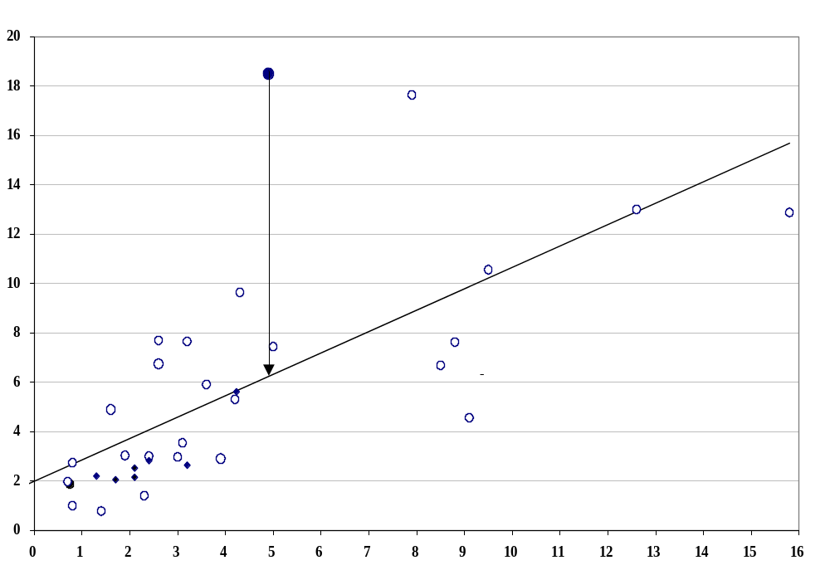

Ranking of the Real Interest Rates for Several Countries
Present rates discounting the inflation projected for the next 12 months
Ranking | Country | % Year |  | Ranking | Country | % Year
1 | Brazil (Nov/05) | 13,4% |  | 8 | Australia | 3.1%
2 | China | 6.3% |  | 10 | Israel | 2.2%
3 | Mexico | 6.1% |  | 13 | England | 2.2%
4 | Turkey | 5.8% |  | 15 | Sweden | 1.8%
5 | India | 3.7% |  | 17 | Netherlands | 1.4%
6 | Poland | 3.4% |  | 18 | USA | 1.0%
7 | Hungry | 3.4% |  | 22 | Canada | 0.6%
9 | South Africa | 3.1% |  | 23 | France | 0.5%
11 | Venezuela | 2.2% |  | 24 | Japan | 0.4%
12 | Hong Kong | 2.2% |  | 25 | Denmark | 0.4%
14 | Colombia | 1.9% |  | 26 | Germany | 0.2%
16 | South Chorea | 1.6% |  | 27 | Austria | 0.1%
19 | Singapore | 0.9% |  | 29 | Italy | -0.1%
20 | Indonesia | 0.8% |  | 30 | Switzerland | -0.2%
21 | Chile | 0.8% |  | 32 | Portugal | -0.6%
28 | Malaysia | 0.0% |  | 33 | Spain | -0.8%
31 | Taiwan | -0.4% |  | 36 | Belgium | -1.2%
34 | Check Republic | -0.9% |  | Averages:
35 | Philippines | -1.2% |  | Developed |  | 0.6%
37 | Russia | -1.9% |  | Emergent Brazil Excluded |  | 1.3%
38 | Thailand | -2.0% |  | Total |  | 1.3%
39 | Greece | -2.3%
40 | Argentina | -4.7%
Average Emergent Brazil Excluded |  | 1.3%
Source: GRC Vision Sep/05
Note: Short interest rate, inflation discounted by the consumer price index (Brazil = IPCA)
Inflation projected by the market 12 months ahead for the IPCA and GRC Vision for the other countries.

Regarding the foreign accounts, after an average of US$ 1.1 billion deficit yearly in the previous government, average annual surplus of US$ 33.5 billion occurred in the present government, closing these last months with US$ 41.9 billion in October.

Among the present businesses that measure the foreign account’s final result, there was a rupture in the model where the Real Plan was inserted, producing an average yearly deficit of US$ 23.3 billion. Beginning in 2003 the average yearly surplus in this government was of US$ 9.6 billion, closing the last twelve months in October having reached US$ 13.1 billion.

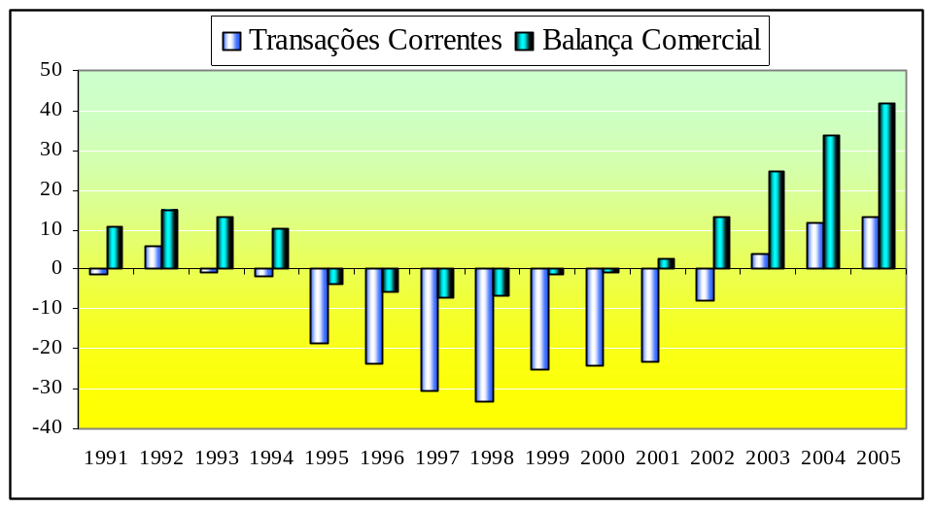

Due to this performance in the foreign accounts, the main external vulnerability indicator, which is the number of years of exports necessary to pay the external debt, fell from 3.5 in the previous government to 2.3 in the present government reaching the level of 1.5 in October.

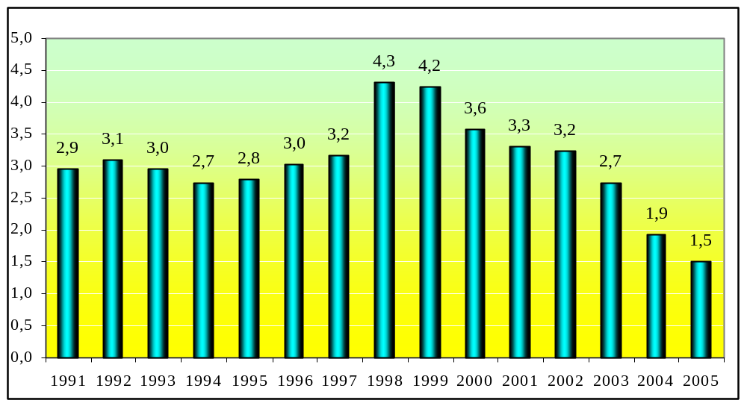

Data from the economic situation also indicate expressive improvements in the Brazilian macroeconomic fundaments.

In the previous FHC government, the economic growth was within an annual average of 2.3%, reaching 2.8% in the present government, and will probably reach 3% in 2005.

The inflation measured by the Consumer Price Index – IPC, fell from an annual average of 10.2% in the previous government to 6.7% in the present government, closing the last twelve months in October registering 4.9%.

Using 1992 = 100 as reference, industrial production reached an average of 123.3 in the previous government, 136.3 in the present government, having reached 142.4 in October 2005. Using the same reference, the average real salary was 109.9 in the previous government, and 110.4 in the present government; being that in October 2005 it had already reached 118.3.

Using December 2004 = 100 as reference, formal employment had an average of 86.6 in the previous government, 98.6 in the present government and in October 2005 it had reached 101.9.

Default fell from an 8.8% average in the previous government to 4.7% in the present government, remaining at this level in October 2005. This is the lowest level in history, loosing only for 2004, when an increase in the personal credit was registered.

The graphs below illustrate the evolution the economic situation indicators went through:
Indicators of the Economic Situation

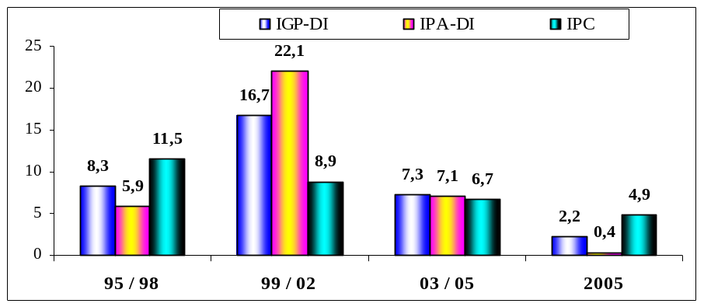

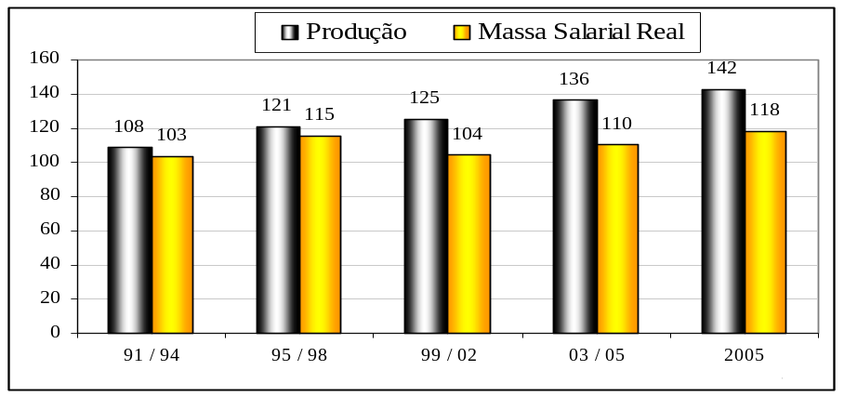

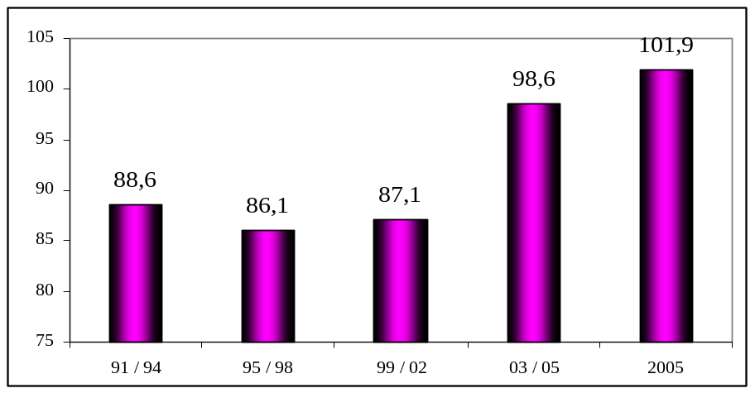

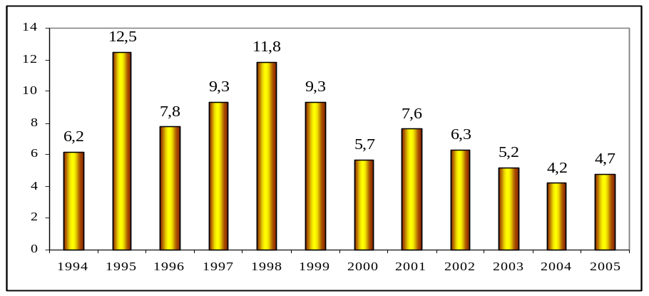
Regarding public finances, history shows that the Central Government and the Brazilian States accumulated high debts throughout the years, which imposed limits to financing the development of public policies. State debts, mainly government bonds, were refinanced by the Central Government between 1997 and 1999. As compensation, the states pay approximately 13% of their net revenue to the Central Government (basically revenue exclusive to credit operations).

Finalizing the refinancing process in May 2000, the Central Government started to shoulder alone the entire foreign bond debt. Since this debt is influenced directly or indirectly by the high Selic rate, the government is unable to totally pay the interests despite the high primary surplus.

The municipalities are not the indebted entities of the federation, even though few exceptions do exist, among which São Paulo municipal government stands-out. The table below presents the recent development of the Brazilian public sector net debt:

Development of the Public Sector Net Debt
Million R$ Oct/05 (IPCA)
Month / year | Dec - 03 |  | Dec - 04 |  | August |  | September |  | October
Debt | R$ mi | %GDP | R$ mi | %GDP | R$ mi | %GDP | R$ mi | %GDP | R$ mi | %GDP | Priv.%
Total Net Debt | 1,029,070 | 57.2 | 1,002,306 | 51.7 | 984,394 | 51.8 | 980,751 | 51.4 | 979,114 | 51.1 | 100.0
Central Government | 629,508 | 35.0 | 596,296 | 30.7 | 599,155 | 31.5 | 600,861 | 31.5 | 601,644 | 31.4 | 61.4
States | 352,551 | 19.6 | 355,485 | 18.3 | 337,433 | 17.8 | 332,436 | 17.4 | 330,296 | 17.2 | 33.7
Municipalities | 47,010 | 2.6 | 50,525 | 2.6 | 47,805 | 2.5 | 47,454 | 2.5 | 47,174 | 2.5 | 4.8
Foreign bond debt TN | 765,500 | 42.5 | 805,221 | 41.5 | 891,496 | 46.9 | 901,507 | 47.2 | 903,785 | 47.2 | 92.3
Source: Central Bank;

The Central Government holds 61.4% of the total debt, the states 33.7% and the municipalities 4.8%. The public sector net debt (PSND) reached R$ 979.1 billion in October, which represents 51.1% of the GDP, against R$ 1,029 billion (57.2% of the GDP) in December 2003.

In October, the debt/GDP ratio was 0.6 percent below the one registered in the beginning of the year. The National Treasury foreign bond debt reached R$ 903.8 billion, corresponding to 47.2% of the GDP and 92.3% of the PSND, having increased in R$ 98.6 billion in updated amounts, as a result of the Central Bank monetary policy.

Considering the resources transported to the public sector in Brazil, these have been growing significantly, being our tax burden (total public sector tax collection divided by the GDP) quite high when compared to countries where the per capita income is similar to ours.

From 1970 to 1993 the tax burden remained practically at 25% of the GDP. After the Real Plan it started to increase, reaching 30% during the first term of the previous government (1995/1998), and began to grow importantly 1.6 percent per year in the second term, especially due to the high Cofins (Contribution for Social Security), PIS (Social Integration Program) and CPMF (contribution on funds transfers) rates. By the end of 2002, it reached 35.8%. Therefore, in only 9 years (1994 / 2002) it increased in almost eleven percent. In 2004 it closed at 36.6%. Regarding the record development of the tax burden, which took place during the previous government, the media remained silent.

Regarding the federative division, in 2004 the Central Government held 58.9% of these resources, the states 24.6% and the municipalities 16.5%. When compared to ten years ago the Central Government increased its participation in 2.6 percent, taken from the states, while the municipalities remained with their 16.5% participation.

The following graphs illustrate the development of the tax burden and the international comparison:

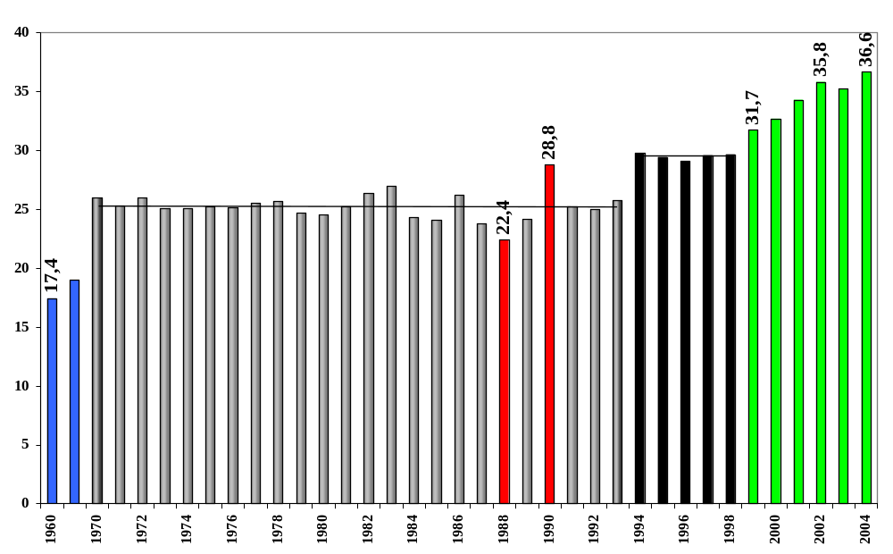

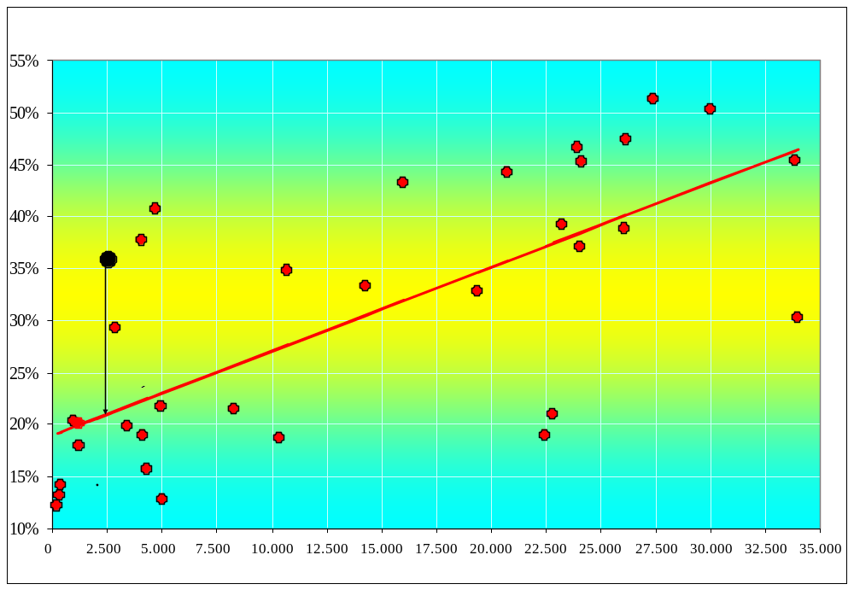

When compared to other countries, the tax burden compatible with our per capita income should be of 21.2% of the GDP. Brazil overtaxes goods and services, social security and labor force when compared to the international picture. In 2002 goods and services represented 47.2% of the Brazilian tax load, against 28.6% in the international average. We ranked the 10th position among the 118 countries, which most charged these taxes. The social security tax represented 17.5% of the tax load against 10.3% in the international average. The taxes situation over labor force is even worse. We only stay behind Sweden in a set of 31 countries, which charge this type of tax. In foreign commerce we are much below the international average level, and concerning income and property taxes we are very near the other countries. Therefore, besides our tax burden being high it lacks quality, concentrating income.

The tax burden must remain high to grant the payment of interest, reducing the fulfillment of social and investment demands regarding infrastructure of the cities and country. This year the federal government interests might reach R$ 170 billion, representing half of all revenue by the Federal Income Tax Department and four times the deficit anticipated for social security this year. This is the federal government’s main budget restriction. The cause responsible for this distortion in the public accounts are the interest rates, which are ten times higher then those practiced in emerging countries, as can be seen in the previous table.

If our nominal interest rates were practiced following the average of emerging countries, we could save R$ 117 billion every year, as can be seen below:

Economy with Interest
Description | Present | Proposal | Difference
Selic (% year) | 18.5 | 6.0 | 12.5
Debt Bonds (R$ bi) | 937 | 937 | 0.0
Interest (R$ bi) | 173 | 56 | 117
Source: Central Bank – Position by the end of Oct / 2005;

While it is not understood that the interest rates do not work as instruments to control inflation, for they dampen the supply more than the demand, we will continue within the trap that limited the previous government and is limiting the present one. The ultimate argument used by those who still believe Selic controls inflation is that keeping it high helps to maintain the Real’s value, which cheapens our imports. We must highlight that the balance of present negotiations, along with direct foreign investments are the real carriers of dollars into our country, much more than investments attracted by Selic. Even if Selic fell quite a bit, the real interests would be much higher than those practiced throughout the world and would continue to attract these speculation applications. The Real would not be devaluated and there would be no risk of inflation.

What actually controls inflation is the opening of the market with globalization, which causes each company to compete with companies from all countries. The graph below illustrates the fall in inflation, which took place during these last ten years, process which Brazil followed.

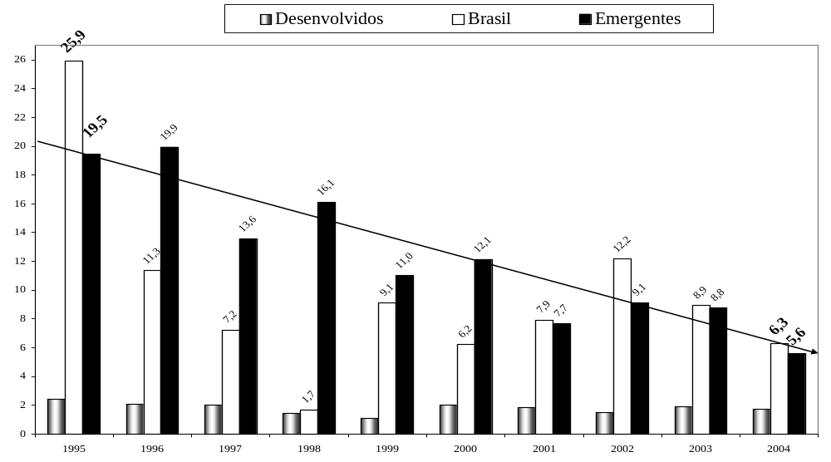

Selic x IGP-DI

Some analysts have stated that the federal government was benefited by the refinancing carried out with the states between 1997 and 1999. They argued that before the refinancing operation, the state debts were adjusted by the Selic rate, and that afterwards they started to be adjusted by the IGP-DI plus an interest rate, usually of 6% per year, being this condition less favorable than the simple adjustment by the Selic rate.

These analysts have used the year of 2000 as a starting point, with no justification, instead of using the date the contracts were signed.

We must keep in mind that the state debts were adjusted by Selic plus a carrying cost and a management fee for the state bank. These, added to the Selic rate were usually quite above the annual interest rate of 6% of the refinanced contracts.

Even disregarding this fact, the table below compares the debt balance adjustments since the beginning of each contract using the Selic rate, with no additional costs, with the IGP-DI + interest rate of each contract.

Comparison between Indexers of the Refinanced State Debts and Selic
 | State | Signature of Contract (dd/mm/yy) | Term (years) | Commitment Limit | Obligations above IGP-DI (%year) | IGP + Interest Adjustment | Selic Adjustment | Selic – IGP Difference
1 | São Paulo | 22/05/97 | 30 | 8.86% - 13.0% | 6% | 301.3% | 398.3% | 97.0%
2 | Mato Grosso | 11/07/97 | 30 | 15.0% | 6% | 295.0% | 390.5% | 95.5%
3 | Distrito Federal | 29/07/97 | 30 | 13.0% | 6% | 293.1% | 382.8% | 89.7%
4 | Ceará | 17/10/97 | 15 | 12.0% | 6% | 285.0% | 353.6% | 68.6%
5 | Bahia | 01/12/97 | 30 | 11.5% - 13.0% | 6% | 279.8% | 340.6% | 60.8%
6 | Rio Grande do Norte | 26/11/97 | 15 | 11.5% - 13.0% | 6% | 279.8% | 340.6% | 60.8%
7 | Sergipe | 27/11/97 | 30 | 11.5% - 13.0% | 6% | 279.8% | 340.6% | 60.8%
8 | Pernambuco | 23/12/97 | 30 | 12.0% | 6% | 272.1% | 329.1% | 57.0%
9 | Maranhão | 22/01/98 | 30 | 13.0% | 6% | 268.7% | 320.1% | 51.4%
10 | Piauí | 20/01/98 | 15 | 13.0% | 6% | 268.7% | 320.1% | 51.4%
11 | Rondônia | 12/02/98 | 30 | 15.0% | 6% | 268.7% | 320.1% | 51.4%
12 | Amazonas | 11/03/98 | 30 | 12.0% | 6% | 262.7% | 311.1% | 48.4%
13 | Espírito Santo | 24/03/98 | 30 | 13.0% | 6% | 258.8% | 304.2% | 45.4%
14 | Goiás | 25/03/98 | 30 | 13% - 15.0% | 6% | 258.8% | 304.2% | 45.4%
15 | Mato Grosso do Sul | 30/03/98 | 30 | 14.0% - 15.0% | 6% | 258.8% | 304.2% | 45.4%
16 | Paraíba | 31/03/98 | 30 | 11.0% - 13.0% | 6% | 258.8% | 304.2% | 45.4%
17 | Paraná | 31/03/98 | 30 | 12.0% - 13.0% | 6% | 258.8% | 304.2% | 45.4%
18 | Roraima | 25/03/98 | 30 | 12.0% | 6% | 258.8% | 304.2% | 45.4%
19 | Santa Catarina | 31/03/98 | 30 | 12.0% - 13.0% | 6% | 258.8% | 304.2% | 45.4%
20 | Acre | 30/04/98 | 30 | 12.0% | 6% | 256.0% | 297.7% | 41.7%
21 | Rio Grande do Sul | 15/04/98 | 30 | 12.0% - 13.0% | 6% | 256.0% | 297.7% | 41.7%
22 | Minas Gerais | 18/02/98 | 30 | 6.79% - 13.0% | 7.5% | 288.4% | 311.1% | 22.7%
23 | Pará | 30/03/98 | 30 | 15.0% | 7.5% | 286.6% | 304.2% | 17.6%
24 | Alagoas | 29/06/98 | 30 | 15.0% | 7.5% | 279.2% | 284.9% | 5.7%
25 | Rio de Janeiro | 29/10/99 | 30 | 12.0% - 13.0% | 6% | 213.6% | 176.7% | -36.9%
 | Average | 18/02/98 |  |  |  | 269.8% | 318.0% | 48.2%
Source: contract data: Federalism and Sub-national Indebtedness: an argument about the state and municipal debt sustainability by Mônica Mora and Fábio Giambiagi – page 14.
Note: the IGP-DI adjustment + interest, and the Selic adjustment were carried out from the date the contract was signed until 31/10/05. After day 15, the next month is considered as reference.

All states were benefited except for Rio de Janeiro. The most benefited state was São Paulo with an adjustment differential of 97.0 percent between Selic rate adjustment and the IGP-DI adjustment plus 6% per year.

The older the date of the contract the greater the benefit achieved by the state.

If a carrying rate plus a 6% per year commission above the Selic index were to be taken in to consideration, the comparison of the benefits achieved by the state would be even greater as can be observed in the following table:

Comparison between Indexers of the Refinanced State Debts and Selic
 | State | Signature of Contract (dd/mm/yy) | Term (years) | Commitment Limit | Obligations above IGP-DI (%year) | IGP + Interest Adjustment | Selic Adjustment + 6% p.a. | Selic – IGP Difference
1 | São Paulo | 22/05/97 | 30 | 8.86% - 13.0% | 6% | 301.3% | 706.2% | 404.9%
2 | Mato Grosso | 11/07/97 | 30 | 15.0% | 6% | 295.0% | 689.6% | 394.6%
3 | Distrito Federal | 29/07/97 | 30 | 13.0% | 6% | 293.1% | 673+6% | 380.5%
4 | Ceará | 17/10/97 | 15 | 12.0% | 6% | 285.0% | 616.5% | 331.5%
5 | Bahia | 01/12/97 | 30 | 11.5% - 13.0% | 6% | 279.8% | 592.5% | 312.7%
6 | Rio Grande do Norte | 26/11/97 | 15 | 11.5% - 13.0% | 6% | 279.8% | 592.5% | 312.7%
7 | Sergipe | 27/11/97 | 30 | 11.5% - 13.0% | 6% | 279.8% | 592.5% | 312.7%
8 | Pernambuco | 23/12/97 | 30 | 12.0% | 6% | 272.1% | 571.3% | 299.2%
9 | Maranhão | 22/01/98 | 30 | 13.0% | 6% | 268.7% | 554.2% | 285.5%
10 | Piauí | 20/01/98 | 15 | 13.0% | 6% | 268.7% | 554.2% | 285.5%
11 | Rondônia | 12/02/98 | 30 | 15.0% | 6% | 268.7% | 554.2% | 285.5%
12 | Amazonas | 11/03/98 | 30 | 12.0% | 6% | 262.7% | 537.0% | 274.3%
13 | Espírito Santo | 24/03/98 | 30 | 13.0% | 6% | 258.8% | 523.3% | 264.5%
14 | Goiás | 25/03/98 | 30 | 13% - 15.0% | 6% | 258.8% | 523.3% | 264.5%
15 | Mato Grosso do Sul | 30/03/98 | 30 | 14.0% - 15.0% | 6% | 258.8% | 523.3% | 264.5%
16 | Paraíba | 31/03/98 | 30 | 11.0% - 13.0% | 6% | 258.8% | 523.3% | 264.5%
17 | Paraná | 31/03/98 | 30 | 12.0% - 13.0% | 6% | 258.8% | 523.3% | 264.5%
18 | Roraima | 25/03/98 | 30 | 12.0% | 6% | 258.8% | 523.3% | 264.5%
19 | Santa Catarina | 31/03/98 | 30 | 12.0% - 13.0% | 6% | 258.8% | 523.3% | 264.5%
20 | Acre | 30/04/98 | 30 | 12.0% | 6% | 256.0% | 510.4% | 254.4%
21 | Rio Grande do Sul | 15/04/98 | 30 | 12.0% - 13.0% | 6% | 256.0% | 510.4% | 254.4%
22 | Minas Gerais | 18/02/98 | 30 | 6.79% - 13.0% | 7.5% | 288.4% | 537.0% | 248.6%
23 | Pará | 30/03/98 | 30 | 15.0% | 7.5% | 286.6% | 523.3% | 236.7%
24 | Alagoas | 29/06/98 | 30 | 15.0% | 7.5% | 279.2% | 485.1% | 205.9%
25 | Rio de Janeiro | 29/10/99 | 30 | 12.0% - 13.0% | 6% | 213.6% | 289.6% | 76.0%
 | Average | 18/02/98 |  |  |  | 269.8% | 550.1% | 280.3%
Source: contract data: Federalism and Sub-national Indebtedness: an argument about the state and municipal debt sustainability by Mônica Mora and Fábio Giambiagi – page 14.
Note: the IGP-DI adjustment + interest, and the Selic adjustment were carried out from the date the contract was signed until 31/10/05. After day 15, the next month is considered as reference.

In this comparison, which better pictures the reality, the state’s advantage was much higher with the refinancing operation.

Since the monetary policy practiced by the Central Bank has always been of very high Selic interest rates, if the states had not undergone refinancing substituting the selic rate + carrying costs + management commission for IGP-DI plus a 6% - 7.5% interest rate per year, their debts would already have exploded a long time ago.

Generally speaking we can consider the year of 1998 as being the most representative in this renegotiation process.

Estadão’s headline last December was “Investment in Lula’s government is the lowest in 25 years”.
To compare the years the IGP-DI was used to correct the inflation effect.
In relation to other indexes, the IGP-DI and IGP-M cause deformities when comparing long historical series.
The use of IPCA (Broad National Consumer Price Index), which is more compatible with other indexes used to measure inflation during long periods, changes the conclusion this newspaper came to.
Investments made by previous governments fall meaningfully, causing the average investments made by the different governments to become much closer.
In the news, it was not clear if the inflation adjustment calculations were carried out month by month. Probably not, case in which the investments performed by governments previous to the Real Plan (July/94) would be much lower.

 |  | Average annual Investment
Billion R$ from 2005 | Years | IGP-DI | IPCA
Figueiredo | 1980-1984 | 12.5 | 9.1
Sarney | 1985-1989 | 17.2 | 14.3
Collor / Itamar | 1990-1994 | 16.7 | 12.9
FHC 1 | 1995-1998 | 16.1 | 12.2
FHC 2 | 1999-2002 | 17.5 | 15.2
Lula | 2003-2005 | 11.6 | 11.7
Lula | 2003-2006 | 12.3 | 12.4

Considering the IPCA, in the 2003 / 2005 average used by the newspaper, Figueiredo stays in last place and Lula in second last.
If the given budget for 2006 is realized, Lula will pass FHC’s first administration.
Unfortunately, the country has been maintaining, during these 25 years, investment levels much below its minimum infrastructure needs. (See apagão - generalized power cuts).

Tax Burden Projection for 2005

With revenues realized for the Central Government, states, and capitals representing 98% of the public sector collection; and assuming that: a) the same variation percentages observed in regard to the same period of 2004 is maintained for the last months of the year and; b) the GDP anticipated for this year reaches R$ 1,910.6 billion (a 3% growth and 5% inflation); the tax collection may reach R$ 715.6 billion and the tax burden 37.45% of the GDP, as can be seen below.

Tax Burden Growth Projection
Revenue realized until October – forecast for November and December
YEAR | 2004 |  | Estimative for 2005 |  | 2004 / 2005 Variation
GDP in million R$ | 1,766,621 |  | 1,910,601
 | Million R$ | % GDP | Million R$ | % GDP | % GDP | %
TOTAL | 634,390 | 35.91 | 715,575 | 37.45 | 1.54 | 100.0
CENTRAL GOVERNMENT | 442,280 | 25.04 | 498,170 | 26.07 | 1.04 | 67.3
INCOME TAX | 110,308 | 6.24 | 129,984 | 6.80 | 0.56 | 36.2
SOCIAL SECURITY | 93,765 | 5.31 | 107,332 | 5.62 | 0.31 | 20.1
CSLL (Social Contribution on Net Income) | 19,575 | 1.11 | 25,627 | 1.34 | 0.23 | 15.1
COFINS (Contribution to Social Security Financing) | 77,593 | 4.39 | 86,383 | 4.52 | 0.13 | 8.4
FGTS (Employee’s Dismisal Fund) | 28,269 | 1.60 | 32,359 | 1.69 | 0.09 | 6.1
IPI (Industrialized Products Tax) | 22,538 | 1.28 | 25,864 | 1.35 | 0.08 | 5.1
CPMF (Contribution on Funds Transfers) | 26,340 | 1.49 | 29,306 | 1.53 | 0.04 | 2.8
PIS (Social Integration Program) | 17,116 | 0.97 | 19,021 | 1.00 | 0.03 | 1.7
IOF (Financial operation tax) | 5,209 | 0.29 | 6,073 | 0.32 | 0.02 | 1.5
SYSTEM “S” (1) | 4,942 | 0.28 | 5,657 | 0.30 | 0.02 | 1.1
EDUCATION SALARY | 4,831 | 0.27 | 5,530 | 0.29 | 0.02 | 1.0
PASEB | 2,301 | 0.13 | 2,557 | 0.13 | 0.00 | 0.0
OTHERS | 803 | 0.05 | 862 | 0.05 | 0.00 | 0.0
OTHER FINANC. CONTRIB. (2) | 1,917 | 0.11 | 2,013 | 0.11 | 0.00 | -0.2
OTHER SOCIAL CONTRIB. (3) | 2,597 | 0.15 | 2,727 | 0.14 | 0.00 | -0.3
CIDE-COMBUSTÍVEL (Fuel Tax) | 7,816 | 0.44 | 7,707 | 0.40 | -0.04 | -2.5
TAX OVER FOREIGN TRADE | 9,181 | 0.52 | 9,168 | 0.48 | -0.04 | -2.6
PUBLIC SERVER SEC. CONTR. | 7,179 | 0.41 |  |  | -0.41 | -26.3
STATES | 165,324 | 9.36 | 186,800 | 9.78 | 0.42 | 27.1
ICMS (Goods and service tax) | 138,275 | 7.83 | 156,315 | 8.18 | 0.35 | 23.0
IPVA (Automobile ownership tax) | 8,910 | 0.50 | 10,559 | 0.55 | 0.05 | 3.1
STATE FEES | 2,881 | 0.16 | 3,509 | 0.18 | 0.02 | 1.3
OTHERS (AIR, ICM, ETC) | 2,860 | 0.16 | 3,337 | 0.17 | 0.01 | 0.8
ITCD (Tax on Inheritance and Gifts) | 710 | 0.04 | 807 | 0.04 | 0.00 | 0.1
STATE SOCIAL SECURITY | 11,688 | 0.66 | 12,272 | 0.64 | -0.02 | -1.2
MUNICIPALITIES | 26,786 | 1.52 | 30,605 | 1.60 | 0.09 | 5.5
ISS (Tax on services) | 9,682 | 0.55 | 11,556 | 0.60 | 0.06 | 3.7
ITBI | 1,851 | 0.10 | 2,222 | 0.12 | 0.01 | 0.7
IPTU (Building and Urban Territorial Tax) | 8,965 | 0.51 | 9,851 | 0.52 | 0.01 | 0.5
MUNICIPAL SOCIAL SECURITY | 3,055 | 0.17 | 3,382 | 0.18 | 0.01 | 0.4
MUNICIPAL FEES | 3,055 | 0.17 | 3,382 | 0.18 | 0.00 | 0.3
OTHER TAXES (4) | 115 | 0.01 | 117 | 0.01 | 0.00 | 0.0
Source until 2004: Tax Studies / Tax Burden; 2005: SRF elaborated by Amir Khair
(1) Includes the following contributions: Allowance for Militaries, FUNDESF, FUNFEN and others
(2) Includes: FUNDAF, CIDE REMESSA and other financial contributions
(3) Contributions for: SENAN, SENAI, SESI, SENAC, SESC, INCRA, SDR, SEST, SENAT, SEBRAE and DPC
(4) Improvement contrib, public illumination tax, Active Debt, Fine and Interest

A 1.54 percent tax burden increase would be taking place in relation to that observed by the Federal Income Tax Department in 2004. The Central Government would be responsible for 67.3% of the increase, the states for 27.1% and the municipalities for 5.5%. The income tax would be responsible for 36.2% of this increase followed by the ICMS (Goods and Service Tax) (23.0%), social security (20.1%), and social contribution of profits (CSLL) with 15.1%.

Debt and Personal Expenditure

Following the position of net debt and personal expenditure of States and Capitals in the end of August according to the correspondent net revenue.

- STATES
Ranking of Net Debt and State Personal Expenditure
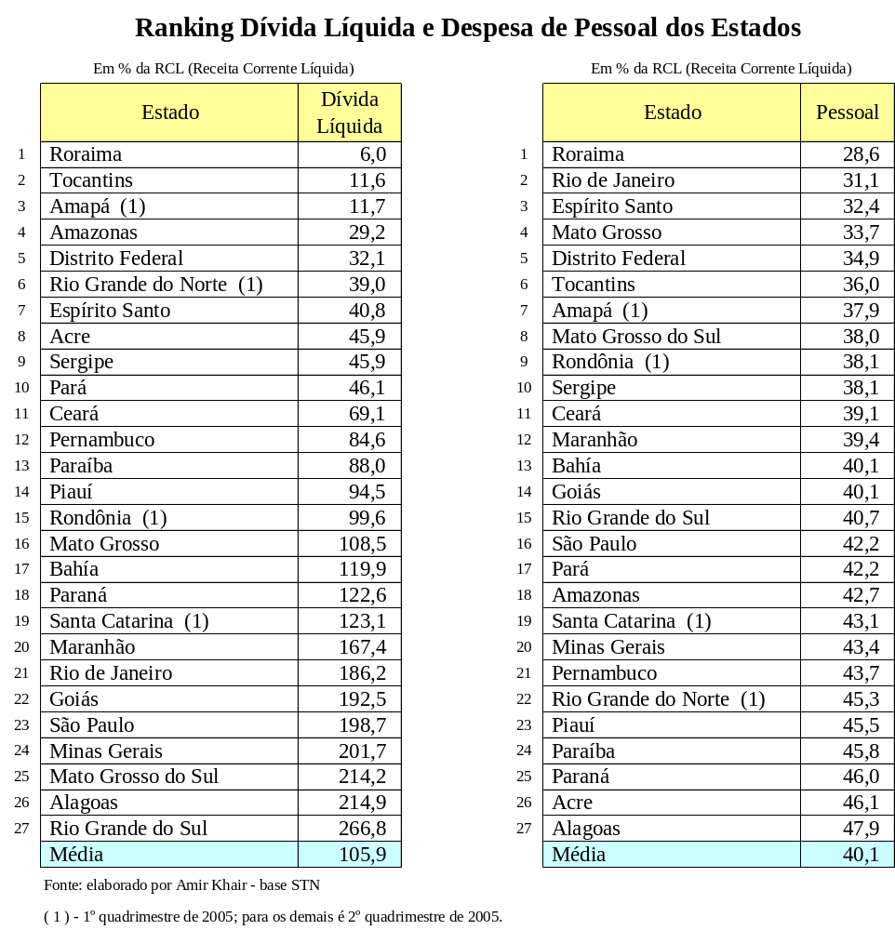

North states were on the first forth positions with the lower level of indebting. 23 States are below the limit fixed by the Senate of 200%. The average debt is by 105,9% of the net current revenue, therefore, they are a little bit over the limit. The best position is Roraima and the worst is Rio Grande do Sul.
All States are below the limit of personal expenditure, which is 49% of net current revenue for the Executive. The average is by 40,1%. The best position is Roraima and the worst is Alagoas.
Roraima is in the first place and Alagoas is in the last of personal expenditure and almost the last in debt.

- Capital
Ranking of Net Debt and Capitals Personal Expenditure
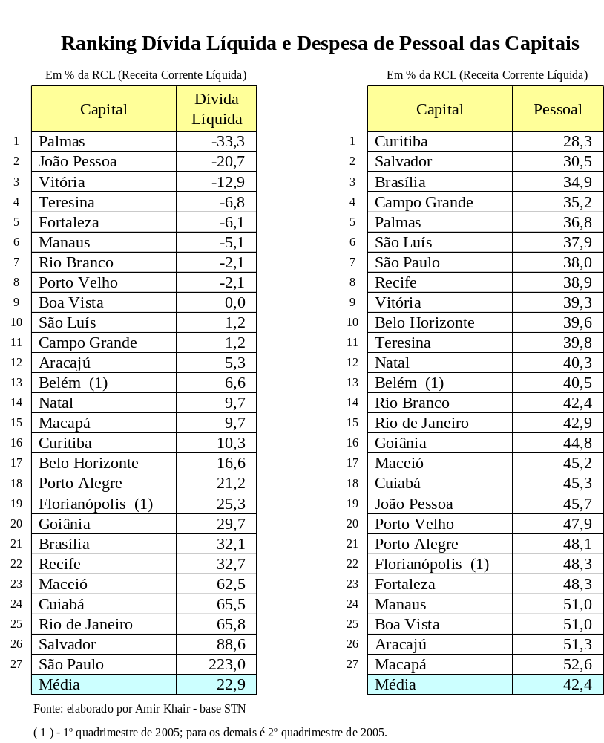
The average debt of the capitals according to their net current revenue is 22,9%, so they are five times below the limit by 120%. There are eight capitals, which have more financial availability than debt, and there are fifteen capitals, which are below 10%. The best position is Palmas and the worst Sao Paulo.

All the capitals are below the personal expenditure limit that is by 54% of the net current revenues in the Executive Level. The average is 42%, above the States that were 40,1%. The best position is Curitiba and the worst is Macapá. The average is by 42,2%, above all the states, which were by 40,1%. The best position is Curitiba and the worst is Macapa.

Parte superior do formulário
- THE TAX REFORM AND THE MUNICIPAL FINANCE

The Nobel laureate James P. Buchanan developed the “fiscal illusion” hypothesis: taxation is diffuse, paid by all. It is embedded in the price of goods, payroll deductions, inflation and growth of the public debt. The benefits of public spending, however, are visible and concentrated in well-defined groups that pressure for expenditure increases, which politicians accommodate in order to maximize their electoral chances. Those paying for increased expenditure are dispersed and can not resist the pressure to spend more. So the tax burden and the public deficit grow.

Other economists reject the theory above, arguing that people can not be fooled forever. In the long term, voters hurt by the ratio of taxes paid to benefits received will vote against politicians exploiting the fiscal illusion. But even when there is no fiscal illusion in the long run, this illusion can operate in the short run, in the view of voters’ difficulty in achieving and processing information needed to decide their vote.

Another electoral incentive operates when a government tries to influence the actions of its successor. It is usual in the Municipalities of Brazil. Elected officials, expecting to leave office after the next election, may expand the deficit spending to capture short-term benefits and reward their supports. The new government, facing an increased debt burden, cannot finance its own programs and will try to repudiate the debts it inherited. Still another electoral incentive arises when politicians compete for central government funding of local projects to strengthen their election campaigns. Since most public spending is financed by national taxes, legislators compete to include projects benefiting their local election districts in the federal budget.

Local governments extract more federal money in several ways. Instead of spending their own resources, they get pledges from federal funds to finance a given program. They also seek new appropriations to complete projects paralyzed by the lack of funds, or they can transfer their debts to the central government. In addition, local governments can get loans from the public or private financial sector with implicit federal guarantees. While there may be no clause in the loan contract binding the central government as guarantor, both the borrower and the lending institution know that federal authorities will pay if the debtor defaults.

Aiming to change this situation and to modernize the tax system, a number of constitutional amendments proposals related to the Tax Reform are being discussed. The main objectives are to reduce tax evasion and to strengthen local revenue mobilization, particularly at the municipal level, within the broad parameters of the current tax legislation. Emphasis on local revenue mobilization reflects the efforts to reduce dependency of lower government levels on grants and transfers from higher government levels, and to foster transparency and accountability of public finances, with greater social control and civil society participation in service delivery.

An important minority defends that taxation simplicity should be its utmost goal and proposes a “tax revolution” which would drastically reduce the number of taxes and thoroughly centralize collection. However most analysts, albeit recognizing that current tax system is too complex requiring an effort toward simplification, elect the effects of taxation on economic efficiency and on competitive conditions as the main reform issues. According to their view, trough state and local own sources of revenue must be preserved – for both economic and political reasons – some limitation of sub national government taxing powers is unavoidable to accomplish those objectives.

The basic question is how municipalities will survive with these changes and what about their autonomy. Everybody agrees that the system should be simpler and its economic effects should mean benefits to the entire society. Local governments are in principle best able to extract information on local preferences and needs. Reform in Brazilian federalism had been motivated by the need to improve macroeconomic governance and little attention had been devoted to allocate efficiency and equity in service delivery.

Critics are divided into three groups: those who propose simplification through tax collection centralization and reduction in the number of taxes (among these, extremists which banner is the single tax), those who believe value added tax (ICMS) is an inadequate source of revenue for sub national governments and those who propose that ICMS should be maintained undergoing further improvements. It is important to mention that ICMS is collected by the States and its revenue is shared with the municipalities. Services except communication and interstate and intermunicipal transportation are excluded from its base and subject to a separate municipal tax (ISS) as was previously described.

For many years has the debate on tax reform in the country been dominated by the concern with the irrationality of the tax system. The consensus has been that the required reform should be able to make the tax system less complex, less inefficient and less obstructive of economic growth, without altering neither the tax burden, nor the shares of the three government levels in the aggregate tax revenue. There may be good reasons to try to conduct an efficiency-enhancing tax reform in Brazil along these lines, but one has to recognize that such reform has an extremely abstract objective. It is not something that can galvanize the electorate. In fact, there are good reasons to believe that that objective has not even been well understood by a large part of the country’s political elite.

Even among those who are perfectly able to grasp the importance of rationalizing the tax system, the dominant view is that tax benefits focused on such objective, substantial as they may be, will only be strongly felt after a number of years. Especially, of course, if the reform contemplates a slow phasing in of the involved changes.

Last but not least, there has been much uneasiness regarding the possible fiscal costs of a reform involving all government levels (mainly the municipalities) facing a hard-budget constraint, where there is a great fear of revenue loss. This fear affects not only mayors and governors, but the central government itself. Only sizable changes in the tax system would be able to assure substantial efficiency gains. However, bolder changes entail higher risk of considerable revenue loss. Of course, the reform could include an agreement on compensation rules within the federation. Yet the fear persists. It is not possible to assure that those rules will not be changed in the future and they would affect the municipal finance strongly.

Those facts seem to establish very unfavorable conditions for the approval of the kind of tax reform the country needs. An important reform that can really make a difference in terms of efficiency gains requires some degree of boldness. But the bolder the reform, the higher the risk of revenue losses. Apprehensions with possible losses tend to be exacerbated by prophecies of overwhelming waves of judicial injunctions brandished by defenders of the virtues of old taxes. Having in mind their hard-budget constraints, mayors and governors tend to oppose bolder changes, unless they can be assured of full compensation of any losses by the Union. The federal government, having to face its own risk of revenue loss, has to decide whether such compensation can be really assured. It may also fear that if the box of a bold tax reform is opened, municipalities may size the opportunity to extract from the Congress a more generous piece of the aggregate tax revenue pie.

For one reason or the other, the federal government has to decide whether it can stand the cost of having to keep a more precarious fiscal stance. Given the public sector’s overindebtedness, the generation of sizable primary surpluses, on a steady basis has become a crucial condition to bring down real interest rates and put the economy on a sustainable expansion path. With the government strongly pressed to deliver economic growth, the idea of abandoning a sound fiscal position to bet on a risk tax reform may not sound very attractive. Economic benefits seem remote and there is no possibility of getting strong popular support out of a reform with such abstract objectives, particularly when the next election seems so near.

References:

Abrucio, Fernando Luiz, Federalism and Democratic Transitions: The New Politics of the Governors in Brazil, University of Minnesota, 2000.

Affonso, Jose Roberto e Raimundo, JCM (1995) Federalismo Fiscal Brasileiro, Rio de Janeiro.

Affonso, Jose Roberto, Brazil: An Evolving Federation, 2000.

Barceinas, Cesar, Structure of government and local Power, The case of Brazil,2003

Bird, R.,and Jantscher,M.C,1992, Improving Tax Administration in Developing Countries, Washington D.C, International Monetary Fund

Castanhar, Jose Cezar, Fiscal federalism in Brazil, Historical Trends

Clark, Giovani, O Município em Face do Direito Econômico,2001, Belo Horizonte.

De Mello, L.R,Jr, 2000, Fiscal Decentralization and Intergovernmental Fiscal Relations,Vol.28

Guardia, Eduardo Refinetti, Fiscal adjustment and Federalism in Brazil, 2004, India

Khair, Amir, Relatorio da ABRASF(Associacao Brasileira das Secretarias de Financas das Capitais) n.44, 2005

Lima, Edilberto Pontes Lima, Transfers from federal government to states and municipalities in Brazil,George Washington University

Martins, Ives Gandra, O Direito Brasileiro e os Desafios da Economia Globalizada,2003,RJ.

Médici, André (1995) Políticas Sociais e Federalismo, in Afonso e Silva.A Federação em
Perspectiva,São Paulo, FUNDAP.

Mendes, Marcos Brazilian Federalism, Instituto Fernand Braudel de Economia Mundial,2003.

Instituto de Pesquisa Aplicada – IPEA(1997).O Brasil na virada do Milênio, Brasília

Rezende,Fernando (1995) Federalismo Fiscal no Brasil, Revista de Politica Economica, vol.15, n10.

Rezende, Fernando, Fiscal Decentralization and Big Cities Financing in Brazil, 1998.

Serra,J. and Afonso,J.R, Financas publicas municipais-trajetorias e mitos, Conjuntura Econômica,1991,Rio de Janeiro

Tavares, M. and others, Principles and Rules in Public Finances: The proposal of The Fiscal Responsibility Law in Brazil, 1999, Brasilia

World Bank, World Bank Indicators, August 2003.

Varzano, Ricardo, Subnational Taxation, BNDES, 2003

What is Federalism by Marcos Mendes and Norman Gall – US and World Government
World Bank Report, “Brazil – Issues in Fiscal Federalism, mimeo, Document of the World Bank, Washington, May 2002
Brazil: An Evolving Federation by Jose Roberto Afonso e Luis de Mello
Until the 1980s, discretionary grants were more common and highly correlated with the electoral cycle.
Mentioned by Edilberto Ponte Lima, “Transfers from federal government to States and municipalities in Brazil”, IBI.

